8.1

Term Effect SumSqr % Contribtn

Model Intercept

Model A -12 288 64.2857

Model B -1 2 0.446429

Model C 4 32 7.14286

Model D -1 2 0.446429

Model AB 6 72 16.0714

Model AC -1 2 0.446429

Model AD -5 50 11.1607

Error BC Aliased

Error BD Aliased

Error CD Aliased

Error ABC Aliased

Error ABD Aliased

Error ACD Aliased

Error BCD Aliased

Error ABCD Aliased

Lenth's ME 22.5856

Lenth's SME 54.0516

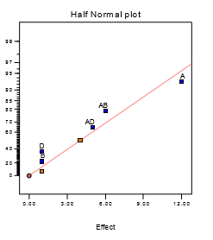

The largest effect is A. The next largest effects are the AB and AD interactions.

Response: yield

ANOVA for Selected Factorial Model

Analysis of variance table [Partial sum of squares]

Sum of Mean F

Source Squares DF Square Value Prob > F

Model 414.00 5 82.80 4.87 0.1791 not significant

A 288.00 1 288.00 16.94 0.0543

B 2.00 1 2.00 0.12 0.7643

D 2.00 1 2.00 0.12 0.7643

AB 72.00 1 72.00 4.24 0.1758

AD 50.00 1 50.00 2.94 0.2285

Residual 34.00 2 17.00

Cor Total 448.00 7

The "Model F-value" of 4.87 implies the model is not significant relative to the noise. There is a 17.91 % chance that a "Model F-value" this large could occur due to noise.

Std. Dev. 4.12 R-Squared 0.9241

Mean 85.00 Adj R-Squared 0.7344

C.V. 4.85 Pred R-Squared -0.2143

PRESS 544.00 Adeq Precision 6.441

Coefficient Standard 95% CI 95% CI

Factor Estimate DF Error Low High VIF

Intercept 85.00 1 1.46 78.73 91.27

A-A -6.00 1 1.46 -12.27 0.27 1.00

B-B -0.50 1 1.46 -6.77 5.77 1.00

D-D -0.50 1 1.46 -6.77 5.77 1.00

AB 3.00 1 1.46 -3.27 9.27 1.00

AD -2.50 1 1.46 -8.77 3.77 1.00

Final Equation in Terms of Coded Factors:

yield = +85.00

-6.00 * A

-0.50 * B

-0.50 * D

+3.00 * A * B

-2.50 * A * D

Final Equation in Terms of Actual Factors:

yield = +85.00000

-6.00000 * A

-0.50000 * B

-0.50000 * D

+3.00000 * A * B

-2.50000 * A * D

the effect of factor A is what I need

8.9

(a).

A: Solvent/Reactant

B: Catalyst/Reactant

C: Temperature

D: Reactant Purity

E: Reactant pH

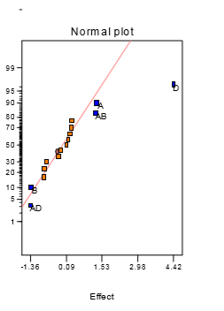

Term Effect SumSqr % Contribtn

Model Intercept

Model A 1.31 6.8644 5.98537

Model B -1.34 7.1824 6.26265

Error C -0.1475 0.087025 0.0758809

Model D 4.42 78.1456 68.1386

Error E -0.8275 2.73902 2.38828

Model AB 1.275 6.5025 5.66981

Error AC -0.7875 2.48062 2.16297

Model AD -1.355 7.3441 6.40364

Error AE 0.3025 0.366025 0.319153

Error BC 0.1675 0.112225 0.0978539

Error BD 0.245 0.2401 0.209354

Error BE 0.2875 0.330625 0.288286

Error CD -0.7125 2.03063 1.77059

Error CE -0.24 0.2304 0.200896

Error DE 0.0875 0.030625 0.0267033

Lenth's ME 1.95686

Lenth's SME 3.9727

Response: color

ANOVA for Selected Factorial Model

Analysis of variance table [Partial sum of squares]

Sum of Mean F

Source Squares DF Square Value Prob > F

Model 106.04 5 21.21 24.53 < 0.0001 significant

A 6.86 1 6.86 7.94 0.0182

B 7.18 1 7.18 8.31 0.0163

D 78.15 1 78.15 90.37 < 0.0001

AB 6.50 1 6.50 7.52 0.0208

AD 7.34 1 7.34 8.49 0.0155

Residual 8.65 10 0.86

Cor Total 114.69 15

The "Model F-value" of 4.87 implies the model is not significant relative to the noise. There is a 17.91 % chance that a "Model F-value" this large could occur due to noise.

Std. Dev. 0.93 R-Squared 0.9246

Mean 2.71 Adj R-Squared 0.8869

C.V. 34.35 Pred R-Squared 0.8070

PRESS 22.14 Adeq Precision 14.734

Coefficient Standard 95% CI 95% CI

Factor Estimate DF Error Low High VIF

Intercept 2.71 1 0.23 2.19 3.23

A-Solvent/Reactant 0.66 1 0.23 0.14 1.17 1.00

B-Catalyst/Reactant -0.67 1 0.23 -1.19 -0.15 1.00

D-Reactant Purity 2.21 1 0.23 1.69 2.73 1.00

AB 0.64 1 0.23 0.12 1.16 1.00

AD -0.68 1 0.23 -1.20 -0.16 1.00

Final Equation in Terms of Coded Factors:

color =

+2.71

+0.66 * A

-0.67 * B

+2.21 * D

+0.64 * A * B

-0.68 * A * D

Final Equation in Terms of Actual Factors:

Color =

+2.70750

+0.65500 * Solvent/Reactant

-0.67000 * Catalyst/Reactant

+2.21000 * Reactant Purity

+0.63750 * Solvent/Reactant * Catalyst/Reactant

-0.67750 * Solvent/Reactant * Reactant Purity

(b).

Diagnostics Case Statistics

Standard Actual Predicted Student Cook's Outlier Run

Order Value Value Residual Leverage Residual Distance t Order 1 -0.63 0.47 -1.10 0.375 -1.500 0.225 -1.616 2

2 2.51 1.86 0.65 0.375 0.881 0.078 0.870 6

3 -2.68 -2.14 -0.54 0.375 -0.731 0.053 -0.713 14

4 1.66 1.80 -0.14 0.375 -0.187 0.003 -0.178 11

5 2.06 0.47 1.59 0.375 2.159 0.466 2.804 8

6 1.22 1.86 -0.64 0.375 -0.874 0.076 -0.863 15

7 -2.09 -2.14 0.053 0.375 0.071 0.001 0.068 10

8 1.93 1.80 0.13 0.375 0.180 0.003 0.171 3

9 6.79 6.25 0.54 0.375 0.738 0.054 0.720 4

10 5.47 4.93 0.54 0.375 0.738 0.054 0.720 5

11 3.45 3.63 -0.18 0.375 -0.248 0.006 -0.236 16

12 5.68 4.86 0.82 0.375 1.112 0.124 1.127 12

13 5.22 6.25 -1.03 0.375 -1.398 0.195 -1.478 9

14 4.38 4.93 -0.55 0.375 -0.745 0.055 -0.727 1

15 4.30 3.63 0.67 0.375 0.908 0.082 0.899 13

16 4.05 4.86 -0.81 0.375 -1.105 0.122 -1.119 7

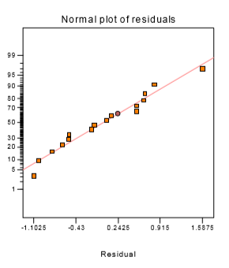 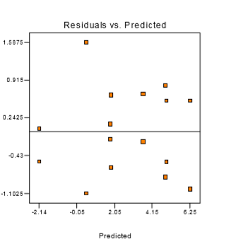

(c).

Response: color

ANOVA for Selected Factorial Model

Analysis of variance table [Partial sum of squares]

Sum of Mean F

Source Squares DF Square Value Prob > F

Model 106.51 7 15.22 14.89 0.0005 significant

A 6.86 1 6.86 6.72 0.0320

B 7.18 1 7.18 8.31 0.0163

C 78.15 1 78.15 76.46 < 0.0001

AB 6.50 1 6.50 6.36 0.0357

AC 7.34 1 7.34 7.19 0.0279

BC 0.24 1 0.24 0.23 0.6409

ABC 0.23 1 0.23 0.23 0.6476

Residual 8.18 8 1.02

Lack of Fit 0.000 0

Pure Error 8.18 8 1.02

Cor Total 114.69 15

The Model F-value of 14.89 implies the model is significant. There is only a 0.05% chance that a "Model F-Value" this large could occur due to noise.

Std. Dev. 1.01 R-Squared 0.9287

Mean 2.71 Adj R-Squared 0.8663

C.V. 37.34 Pred R-Squared 0.7148

PRESS 32.71 Adeq Precision 11.736

Coefficient Standard 95% CI 95% CI

Factor Estimate DF Error Low High VIF

Intercept 2.71 1 0.25 2.12 3.23

A-Solvent/Reactant 0.66 1 0.25 0.0772 1.24 1.00

B-Catalyst/Reactant -0.67 1 0.25 -1.25 -0.087 1.00

D-Reactant Purity 2.21 1 0.25 1.63 2.79 1.00

AB 0.64 1 0.25 0.055 1.22 1.00

AD -0.68 1 0.25 -1.26 -0.095 1.00

Final Equation in Terms of Coded Factors:

color =

+2.71

+0.66 * A

-0.67 * B

+2.21 * D

+0.64 * A * B

-0.68 * A * D

Final Equation in Terms of Actual Factors:

Color =

+2.70750

+0.65500 * Solvent/Reactant

-0.67000 * Catalyst/Reactant

+2.21000 * Reactant Purity

+0.63750 * Solvent/Reactant * Catalyst/Reactant

-0.67750 * Solvent/Reactant * Reactant Purity

8.11

(a).

|  |  |  |  |  |  |
| --- | --- | --- | --- | --- | --- |
| A | B | C | D=BE | E=AC |  |
| - | - | - | - | + | e |
| + | - | - | + | - | ad |
| - | + | - | + | + | bde |
| + | + | - | - | - | ab |
| - | - | + | + | - | cd |
| + | - | + | - | + | ace |
| - | + | + | - | - | bc |
| + | + | + | + | + | abcde |

(b).

I=BDE=ACE=ABCD

|  |  |  |  |  |  |  |  |  |  |
| --- | --- | --- | --- | --- | --- | --- | --- | --- | --- |
| A | (BDE) | =ABDE | A | (ACE) | =CE | A | (ABCD) | =BCD | A=ABDE=CE=BCD |
| B | (BDE) | =DE | B | (ACE) | =ABCE | B | (ABCD) | =ACD | B=DE=ABCE=ACD |
| C | (BDE) | =BCDE | C | (ACE) | =AE | C | (ABCD) | =ABD | C=BCDE=AE=ABD |
| D | (BDE) | =BE | D | (ACE) | =ACDE | D | (ABCD) | =ABC | D=BE=ACDE=ABC |
| E | (BDE) | =BD | E | (ACE) | =AC | E | (ABCD) | =ABCDE | E=BD=AC=ABCDE |
| AB | (BDE) | =ADE | AB | (ACE) | =BCE | AB | (ABCD) | =CD | AB=ADE=BCE=CD |
| AD | (BDE) | =ABE | AD | (ACE) | =CDE | AD | (ABCD) | =BC | AD=ABE=CDE=BC |

(c).

Term Effect SumSqr % Contribtn

Model Intercept

Model A -1.525 4.65125 5.1831

Model B -5.175 53.5613 59.6858

Model C 2.275 10.3512 11.5349

Model D -0.675 0.91125 1.01545

Model E 2.275 10.3513 11.5349

(d).

Response: yield

ANOVA for Selected Factorial Model

Analysis of variance table [Partial sum of squares]

Sum of Mean F

Source Squares DF Square Value Prob > F

Model 79.83 5 15.97 3.22 0.2537 not significant

A 4.65 1 4.65 0.94 0.4349

B 53.56 1 53.56 10.81 0.0814

C 10.35 1 10.35 2.09 0.2853

D 0.91 1 0.91 0.18 0.7098

E 10.35 1 10.35 2.09 0.2853

Residual 9.91 2 4.96

Cor Total 89.74 7

The "Model F-value" of 3.22 implies the model is not significant relative to the noise. There is a 25.37 % chance that a "Model F-value" this large could occur due to noise.

Std. Dev. 2.23 R-Squared 0.8895

Mean 19.24 Adj R-Squared 0.6134

C.V. 11.57 Pred R-Squared -0.7674

PRESS 158.60 Adeq Precision 5.044

Coefficient Standard 95% CI 95% CI

Factor Estimate DF Error Low High VIF

Intercept 19.24 1 0.79 15.85 22.62

A-Condensation -0.76 1 0.79 -4.15 2.62 1.00

B-Material 1 -2.59 1 0.79 -5.97 0.80 1.00

C-Solvent 1.14 1 0.79 -2.25 4.52 1.00

D-Time -0.34 1 0.79 -3.72 3.05 1.00

E-Material 2 1.14 1 0.79 -2.25 4.52 1.00

Final Equation in Terms of Coded Factors:

Yield =

+19.24

-0.76 * A

-2.59 * B

+1.14 * C

-0.34 * D

+1.14 * E

Final Equation in Terms of Actual Factors:

yield =

+19.23750

-0.76250 * Condensation

-2.58750 * Material 1

+1.13750 * Solvent

-0.33750 * Time

+1.13750 * Material 2

(e).

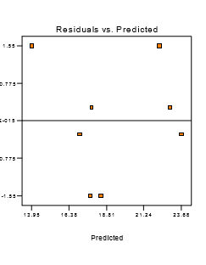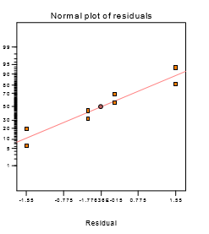

8.24

|  |  |  |  |  |  |  |  |
| --- | --- | --- | --- | --- | --- | --- | --- |
| A | B | C | D | E=ABCD |  | Blocks=AB | Block |
| - | - | - | - | + | e | + | 1 |
| + | - | - | - | - | a | - | 2 |
| - | + | - | - | - | b | - | 2 |
| + | + | - | - | - | abe | + | 1 |
| - | - | + | - | - | c | + | 1 |
| + | - | + | - | + | ace | - | 2 |
| - | + | + | - | + | bce | + | 1 |
| + | + | + | - | - | d | + | 1 |
| + | - | - | + | + | ade | - | 2 |
| - | + | - | + | + | bde | - | 2 |
| + | + | - | + | - | abd | + | 1 |
| - | - | + | + | + | cde | + | 1 |
| + | - | + | + | - | acd | - | 2 |
| - | + | + | + | - | bcd | - | 2 |
| + | + | + | + | + | abcde | + | 1 |